MODULE 9
GitHub Repository Link: https://github.com/devcnx/csd440

Deliverables

Drop Table — Clean slate before testing (or 'Nothing To Drop' if table absent)
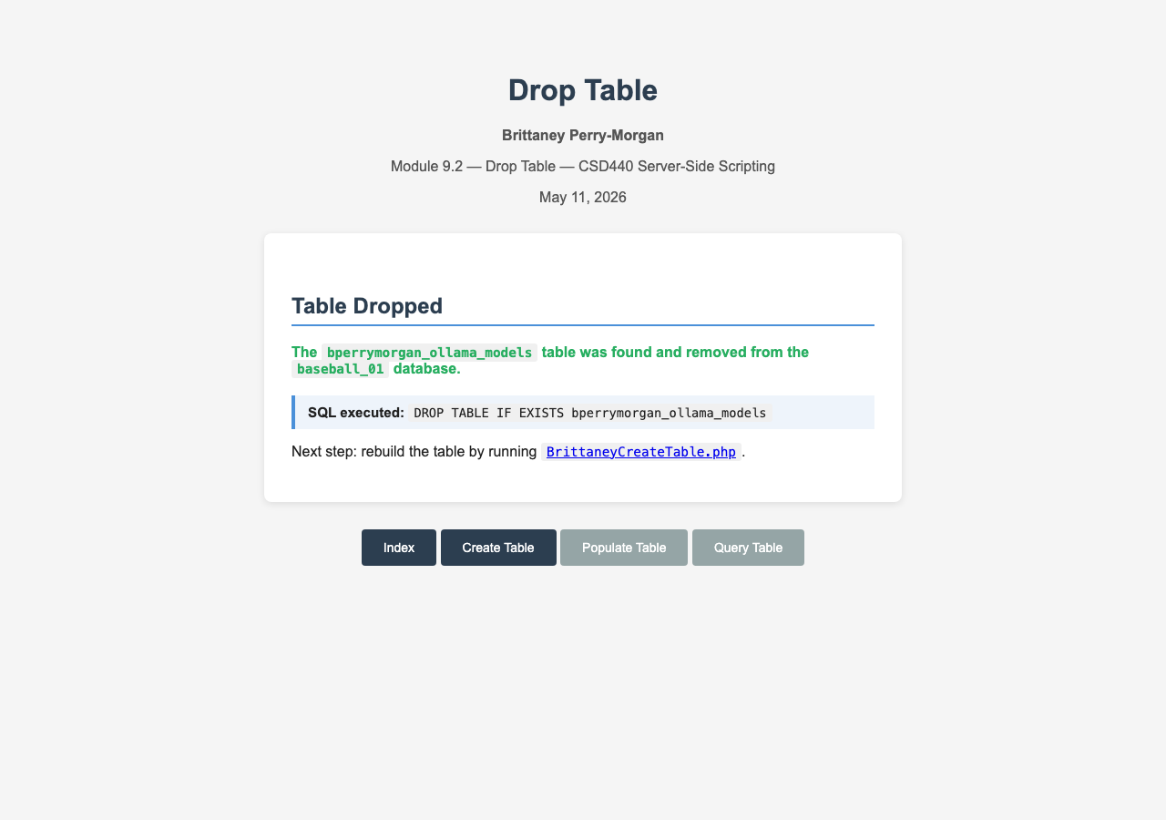

Create Table — Schema confirmed with 8 columns
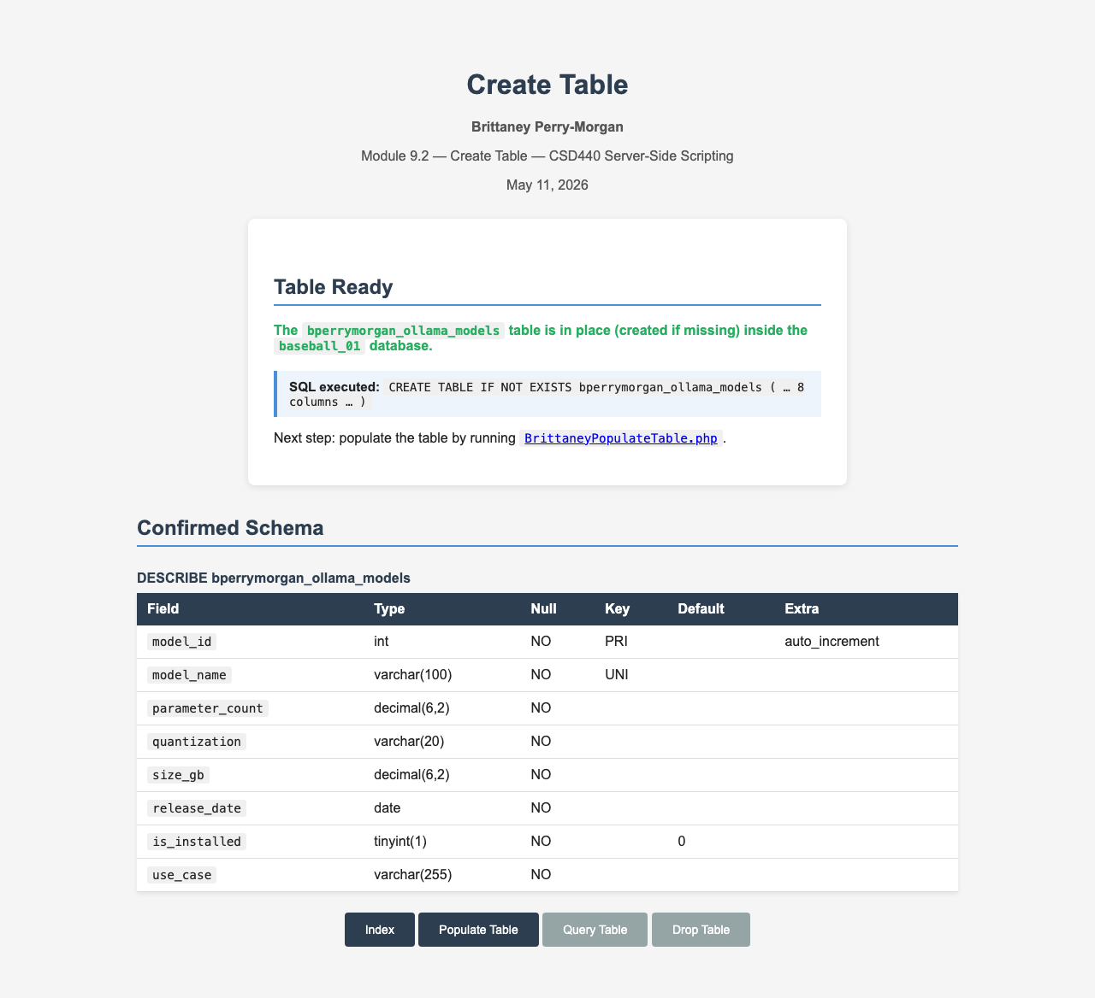

Populate Table — 8 seed rows loaded
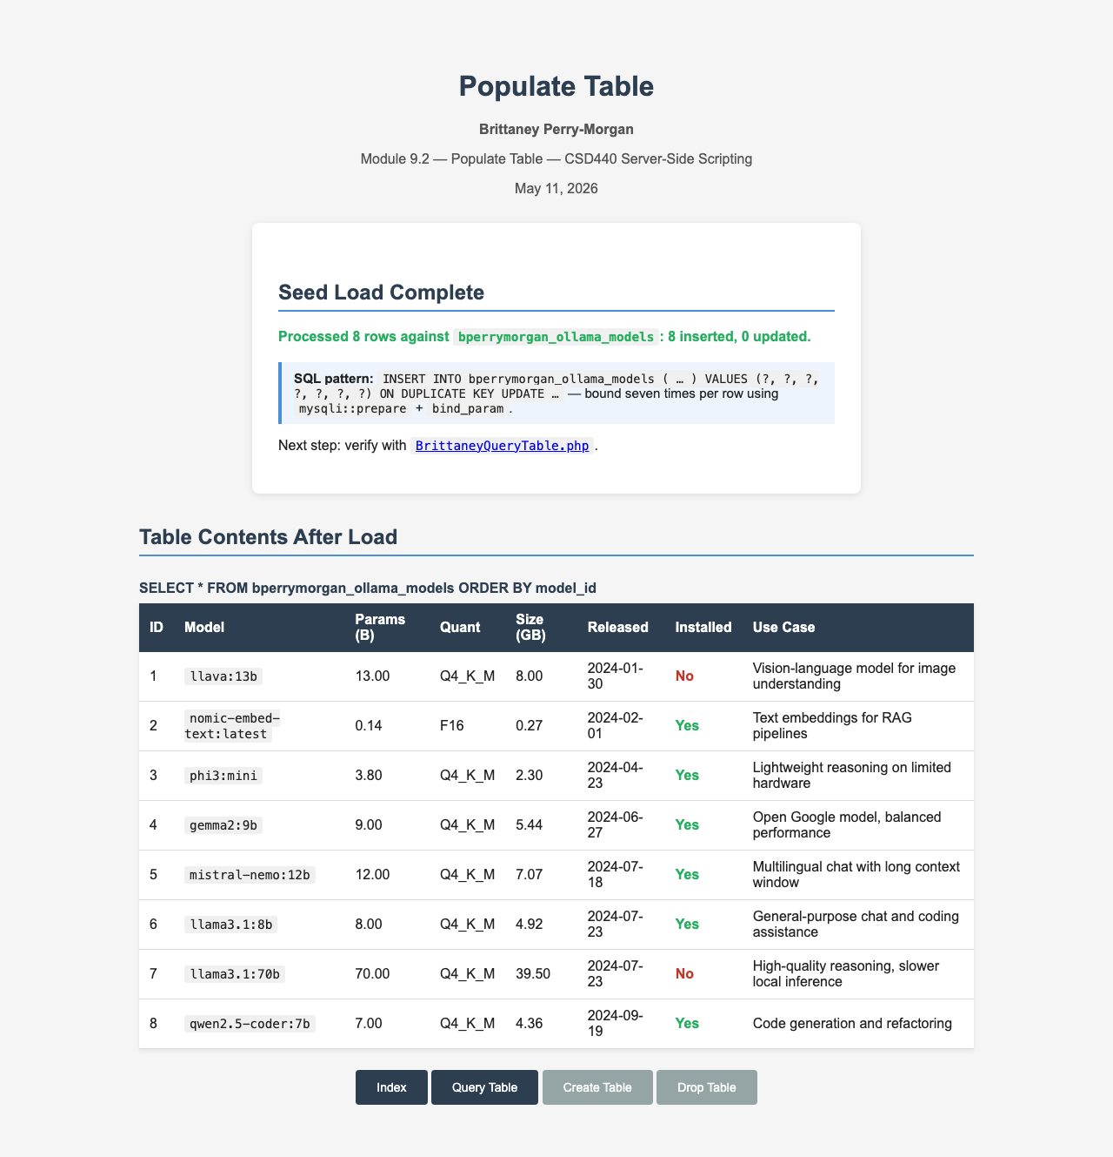

Query Table — Four static SELECT queries against populated data
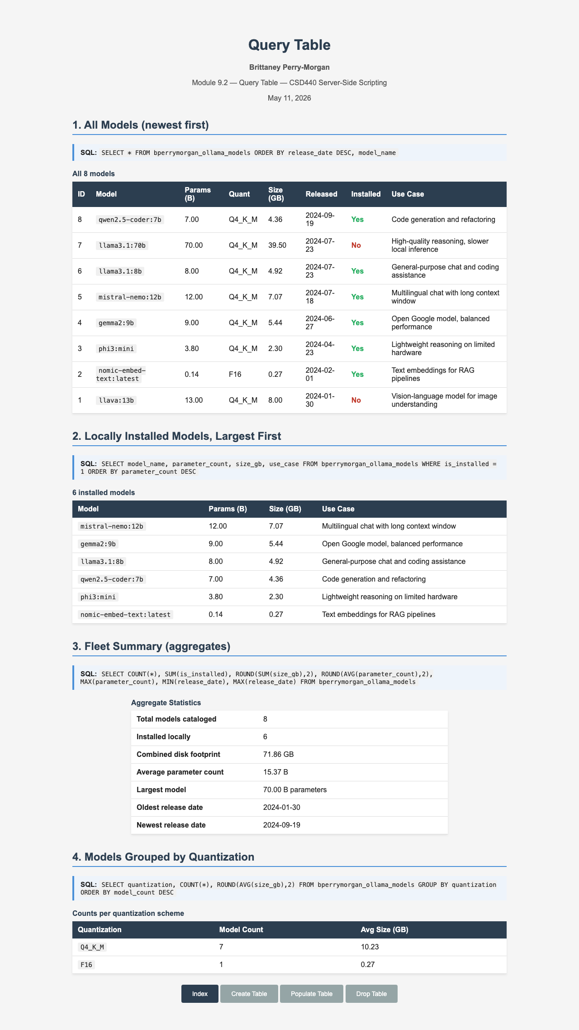

Index — Database status showing 8 rows, navigation to all pages
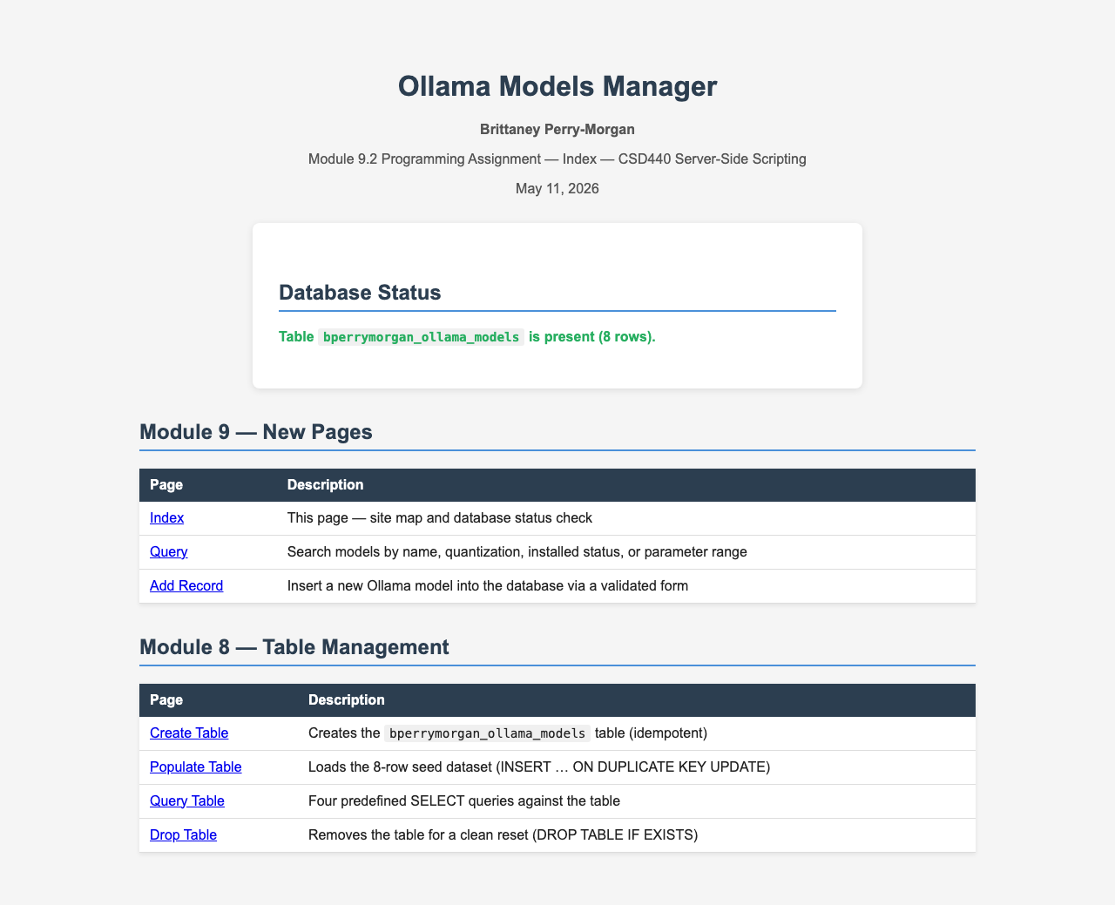

Add Record — Empty form ready for input
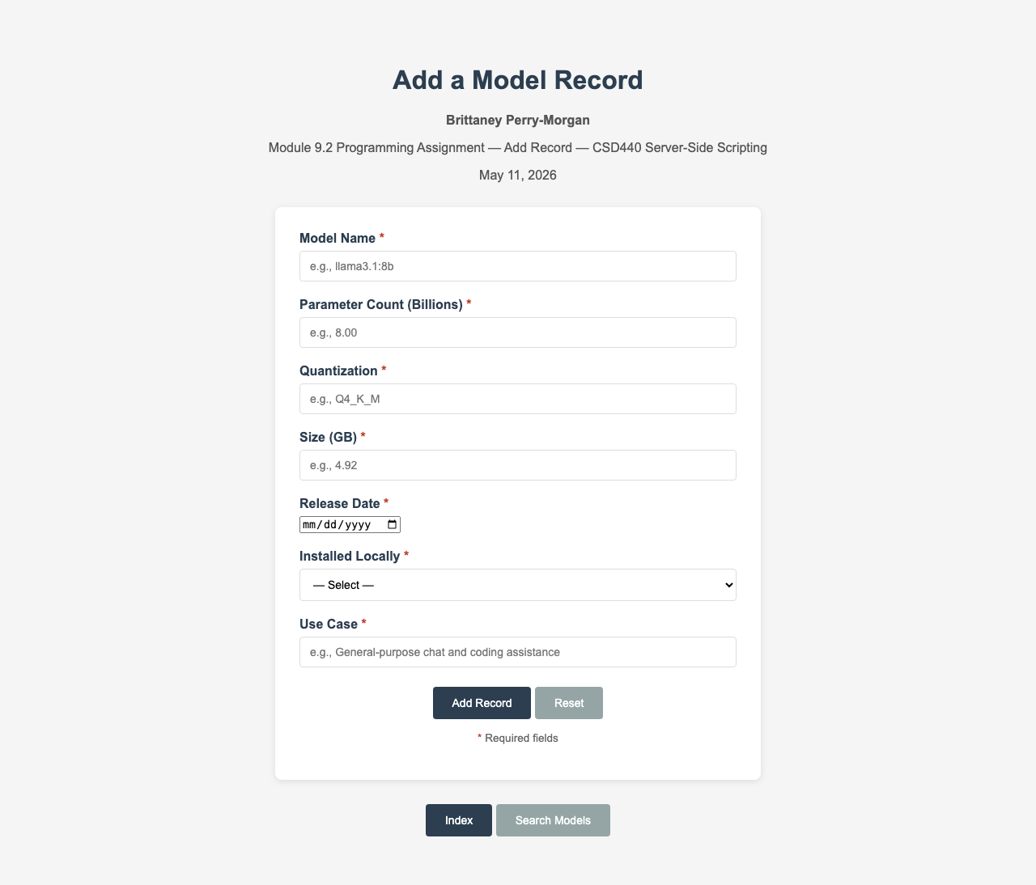

Add Record — Validation errors when submitted empty
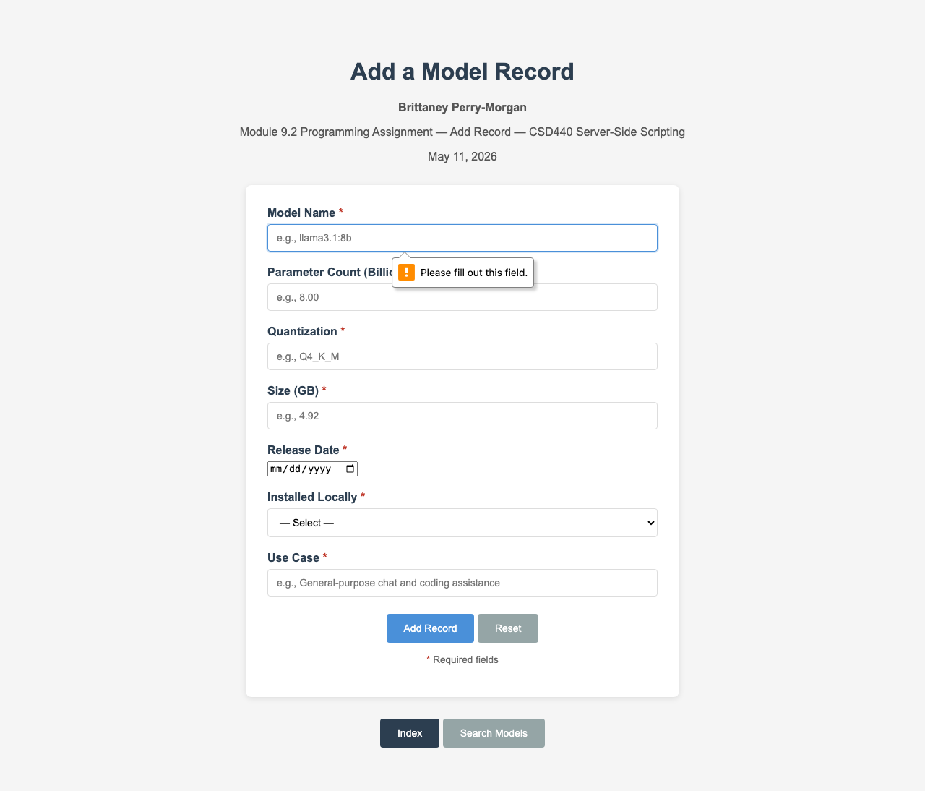

Add Record — Successful insertion of test-model:7b
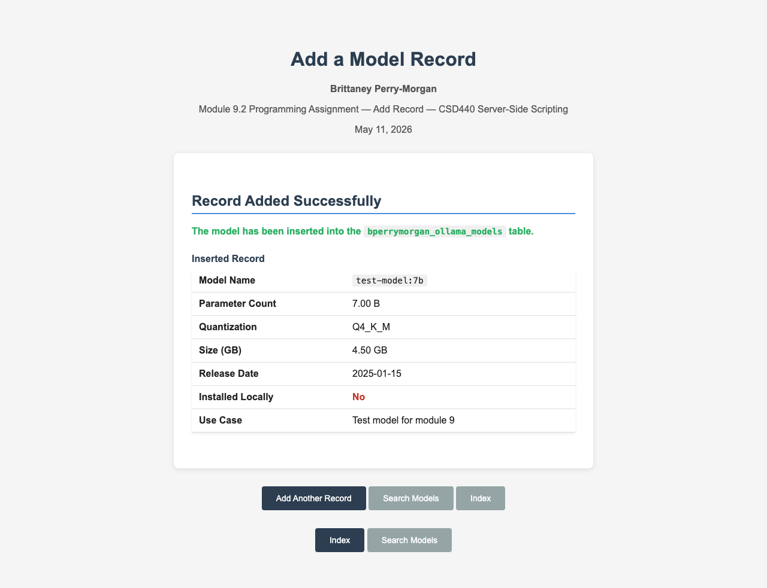

Add Record — Duplicate name error (unique constraint)
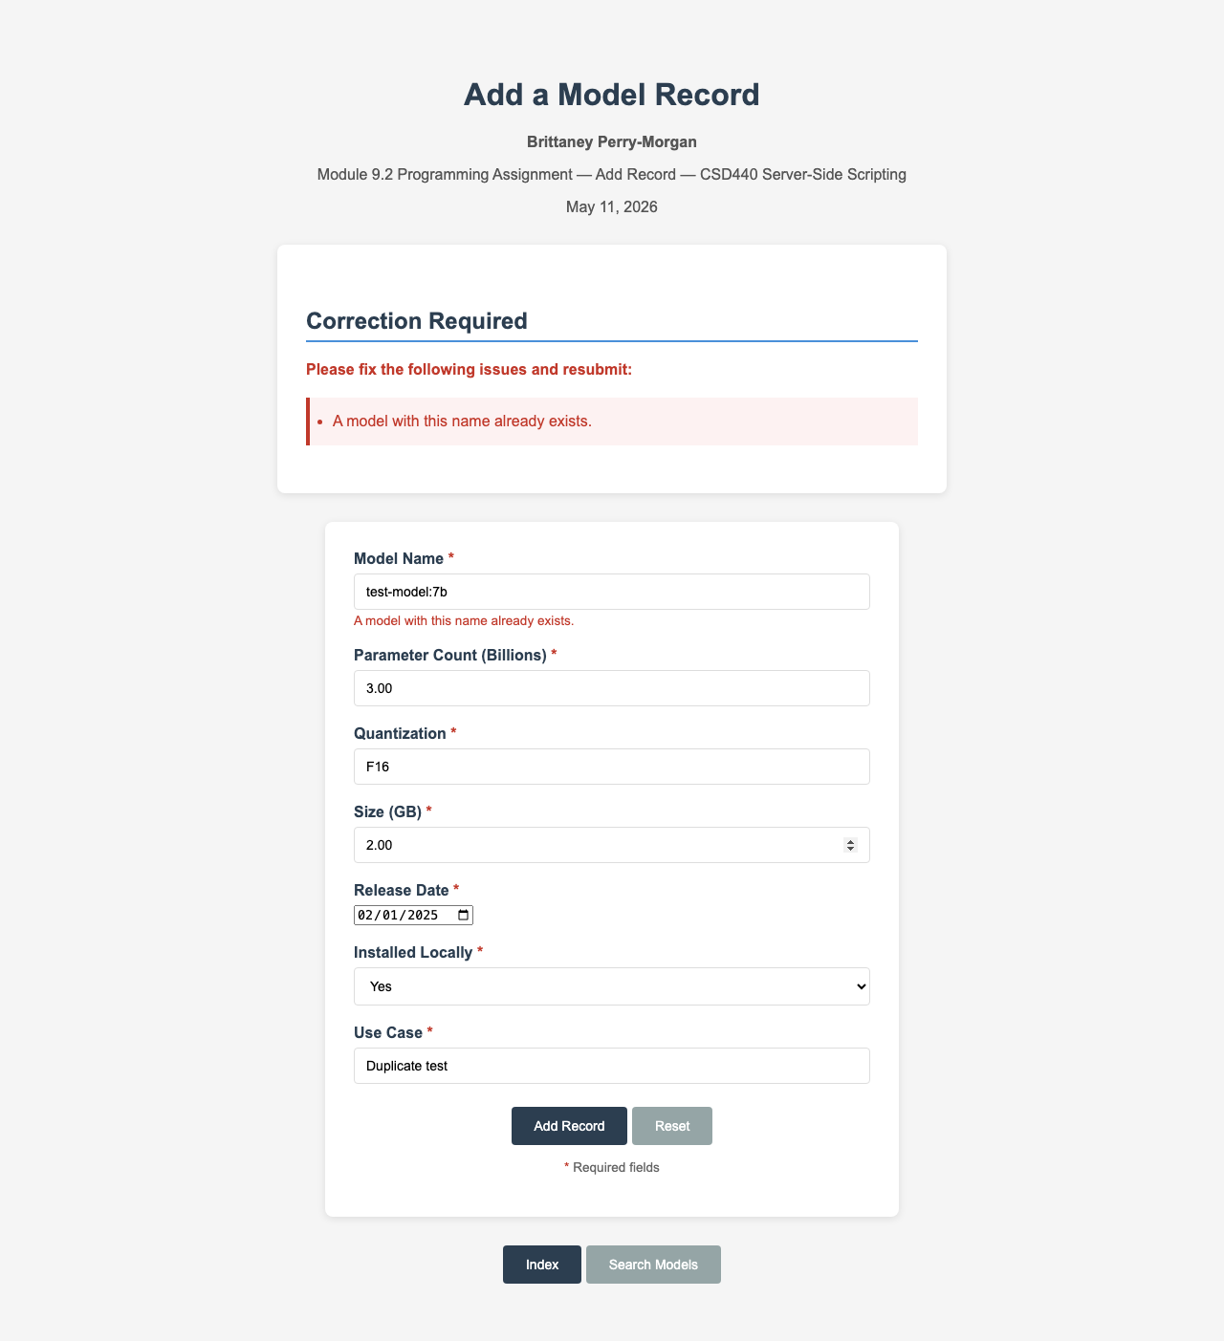

Search — All models with no filters applied (9 rows)
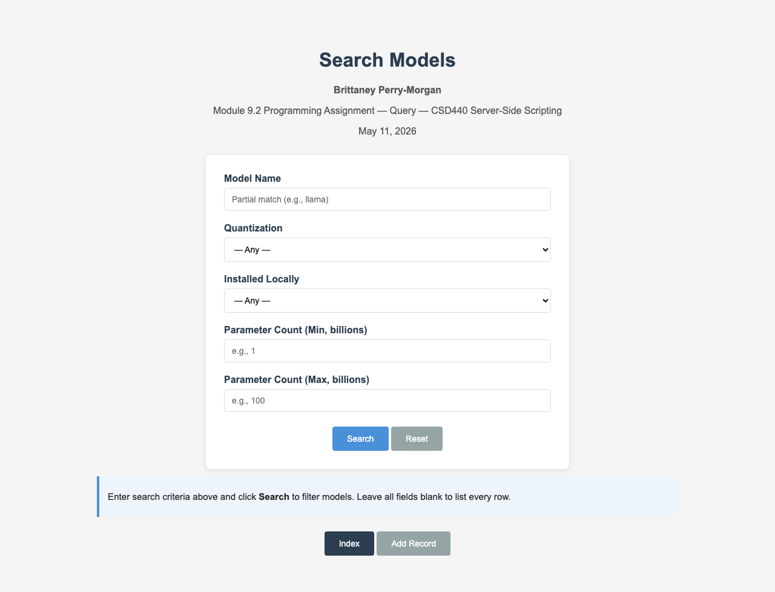

Search — Partial name match for 'llama'
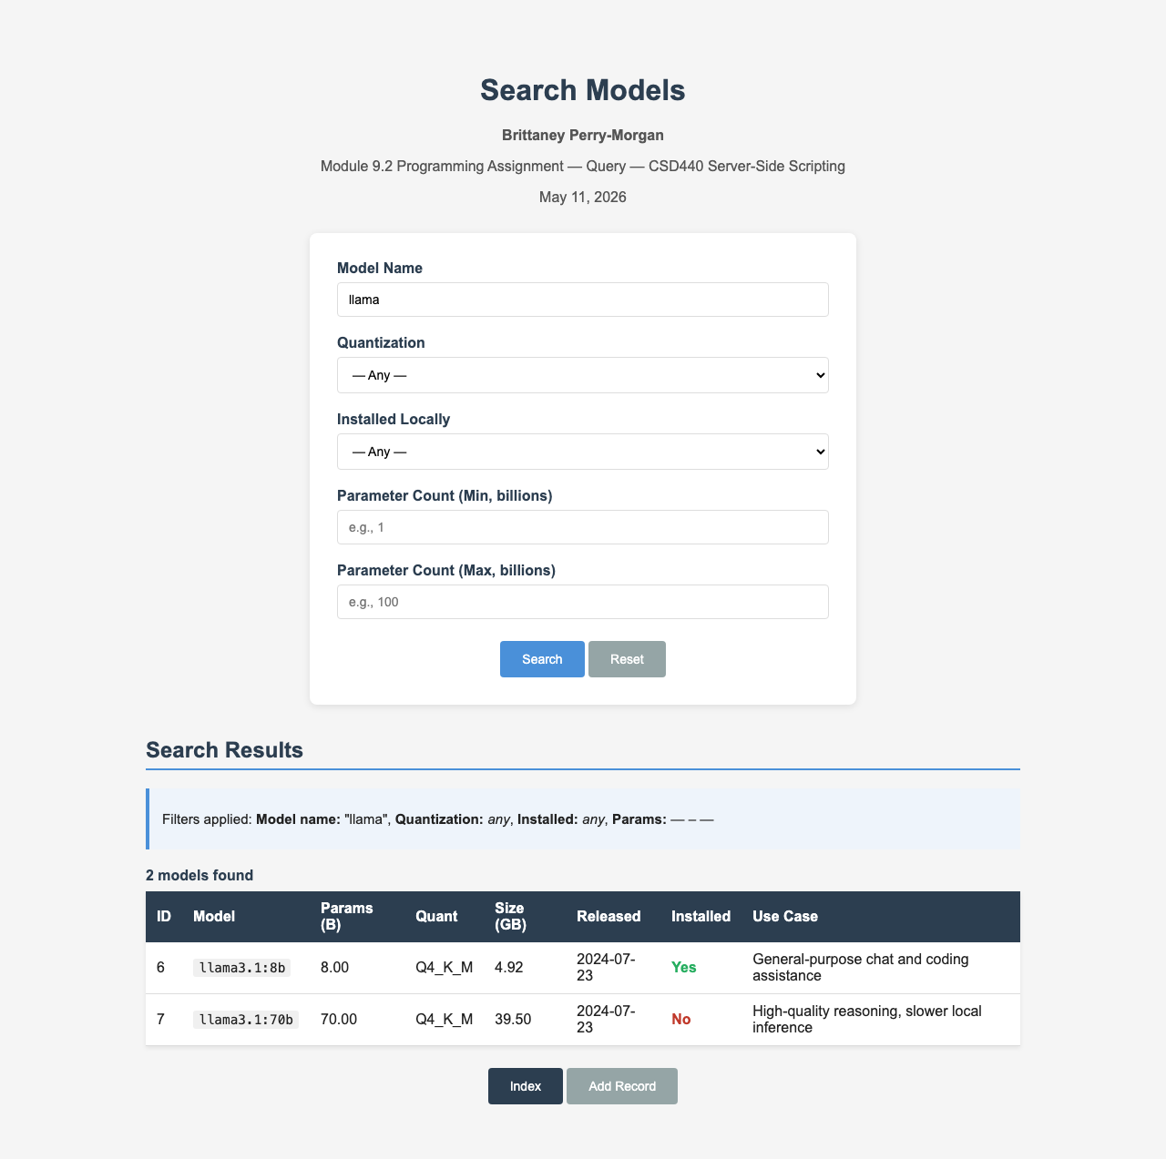

Search — Filtering by installed status (Yes)
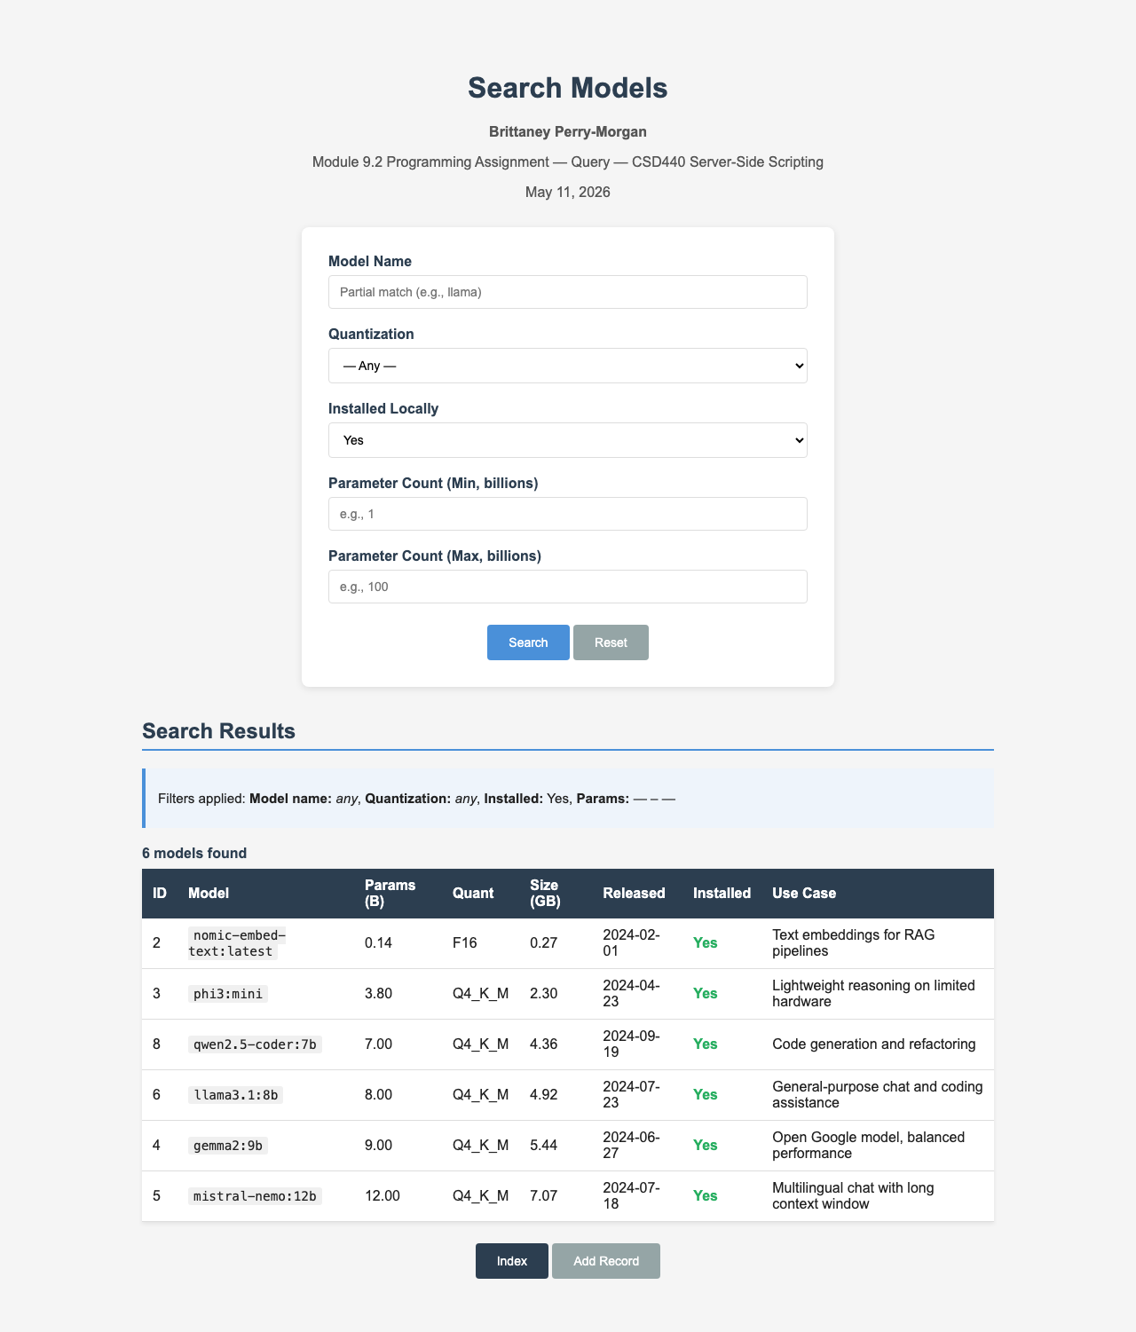

Search — Parameter range filter (10–20 billion)
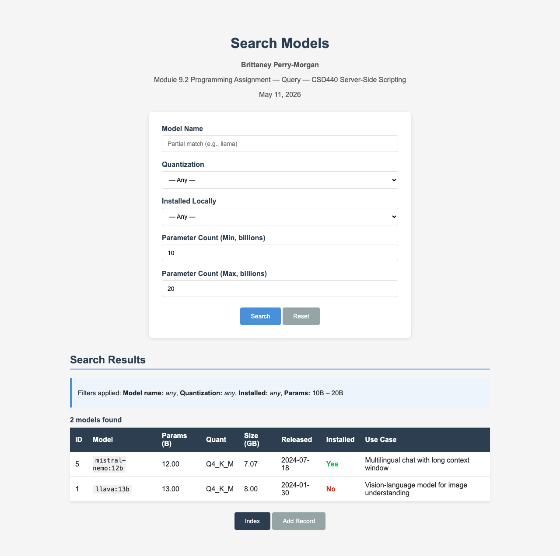

Search — No results for 'zzzzz'
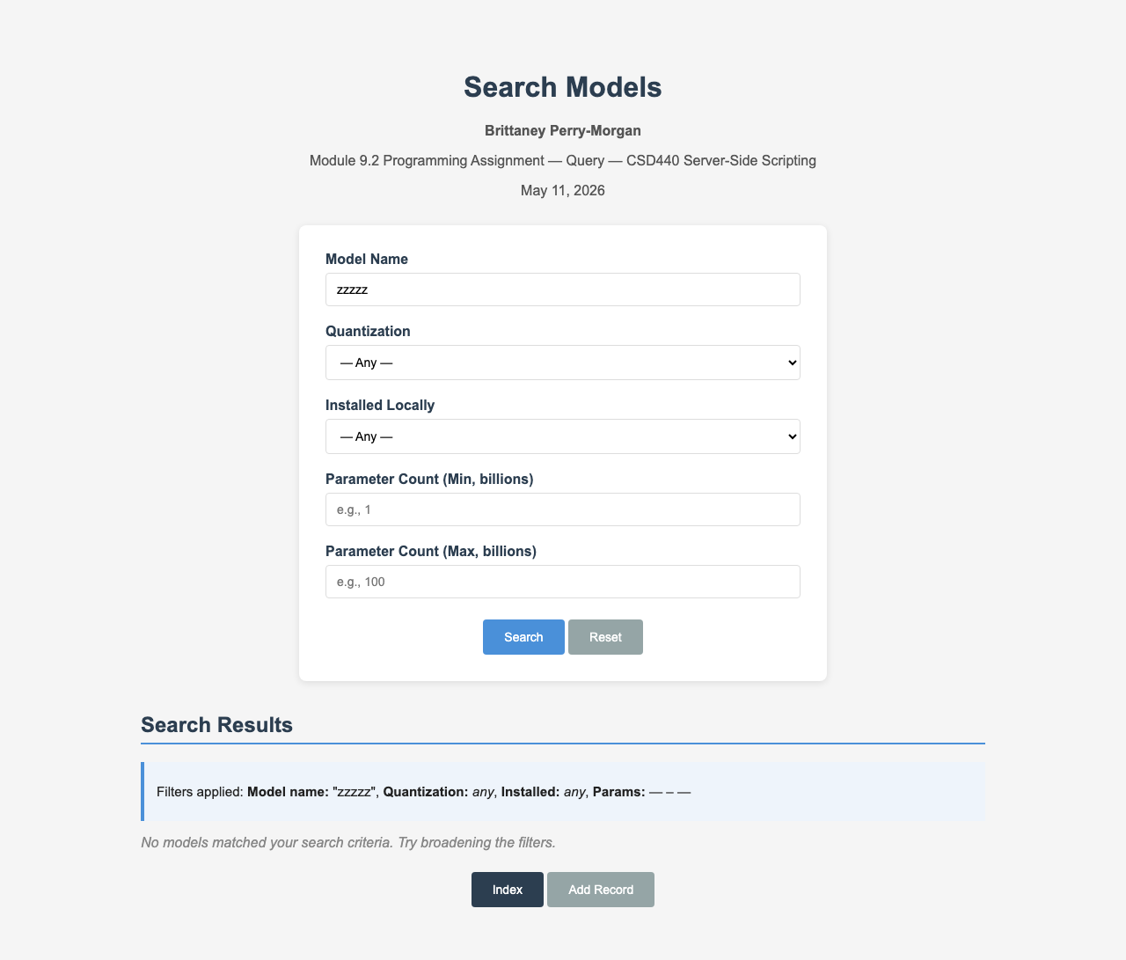

Query Table — Shows 9 rows after adding test record
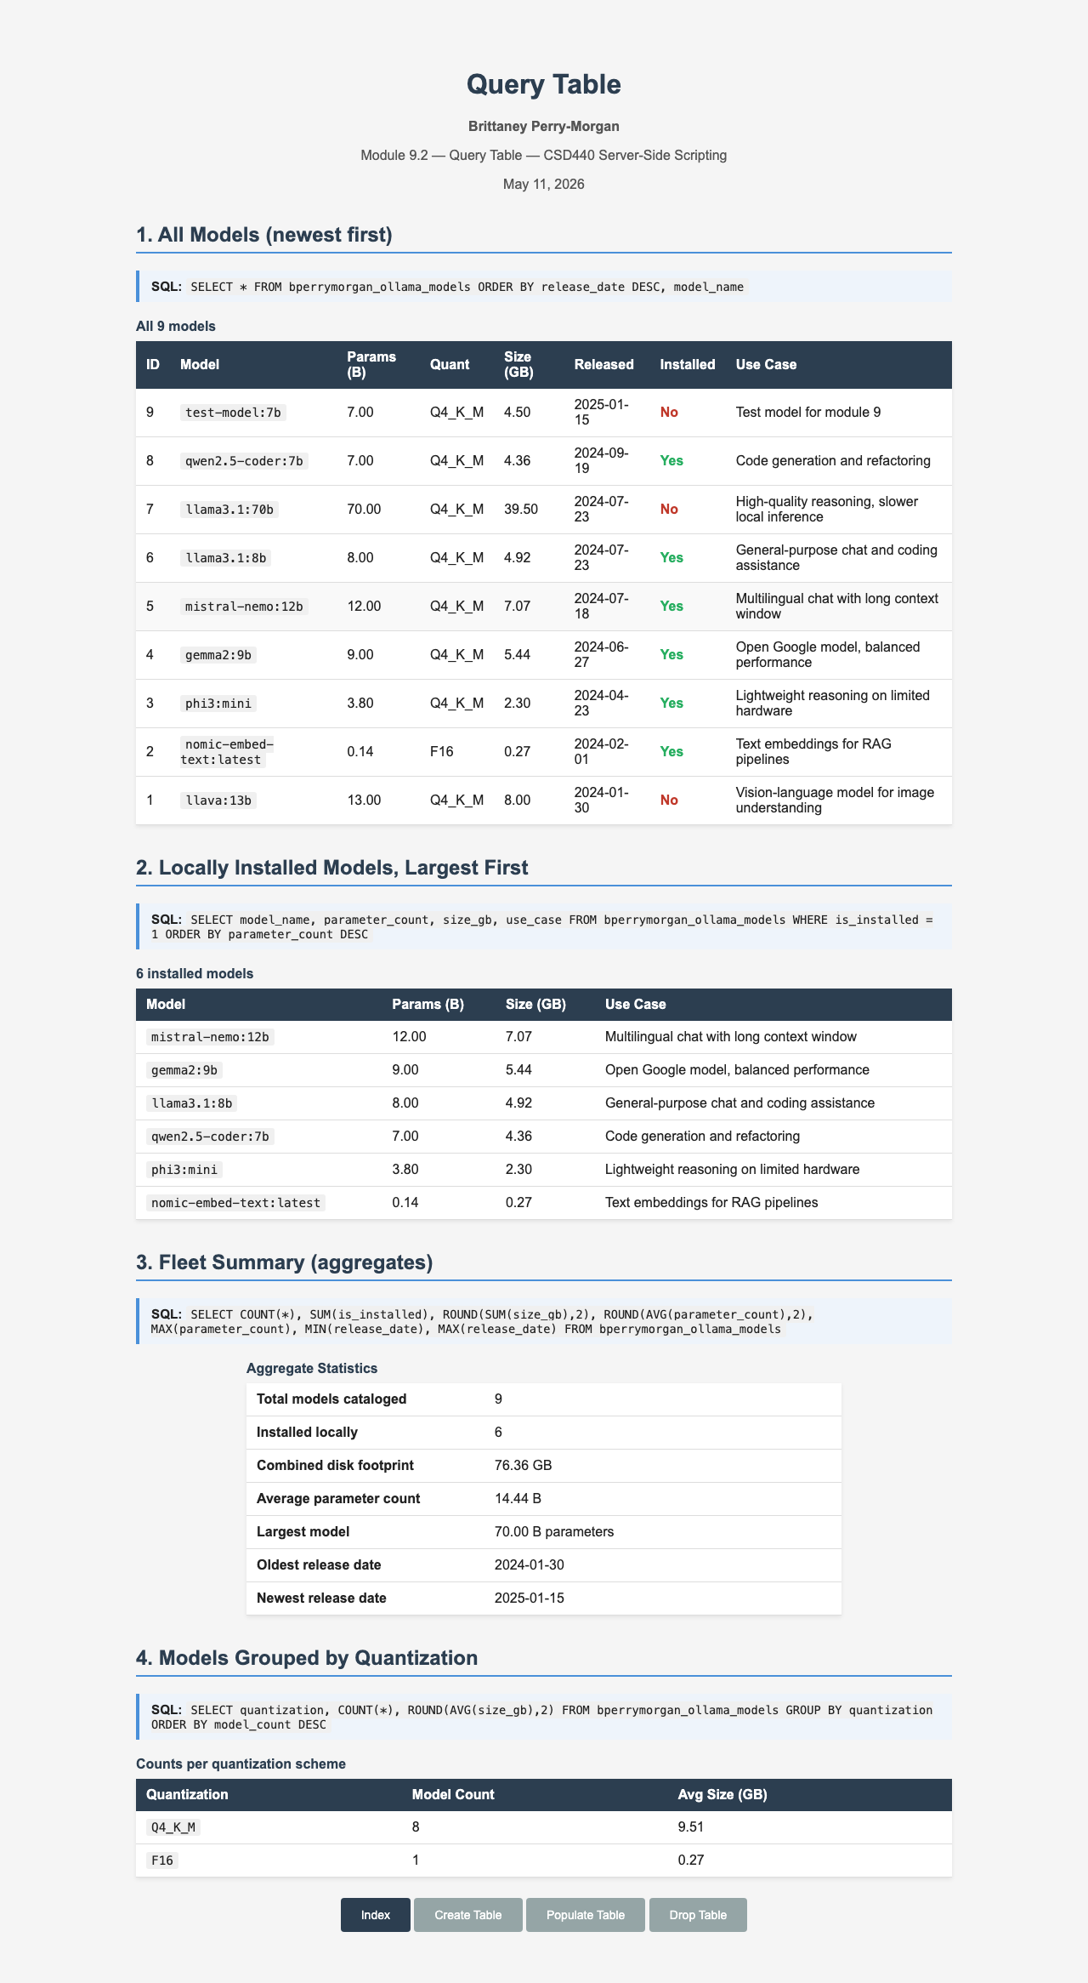

Drop Table — Table dropped successfully


Drop Table — Idempotent re-run ('Nothing To Drop')
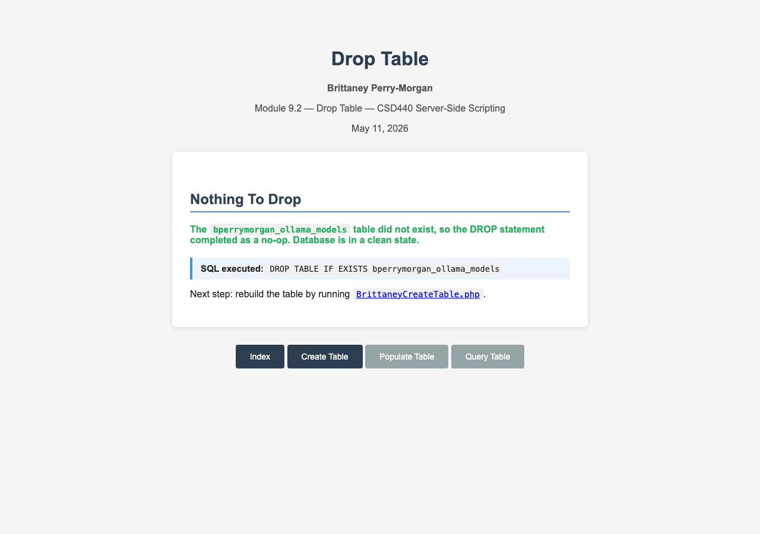

Query Table — Errors after table has been dropped
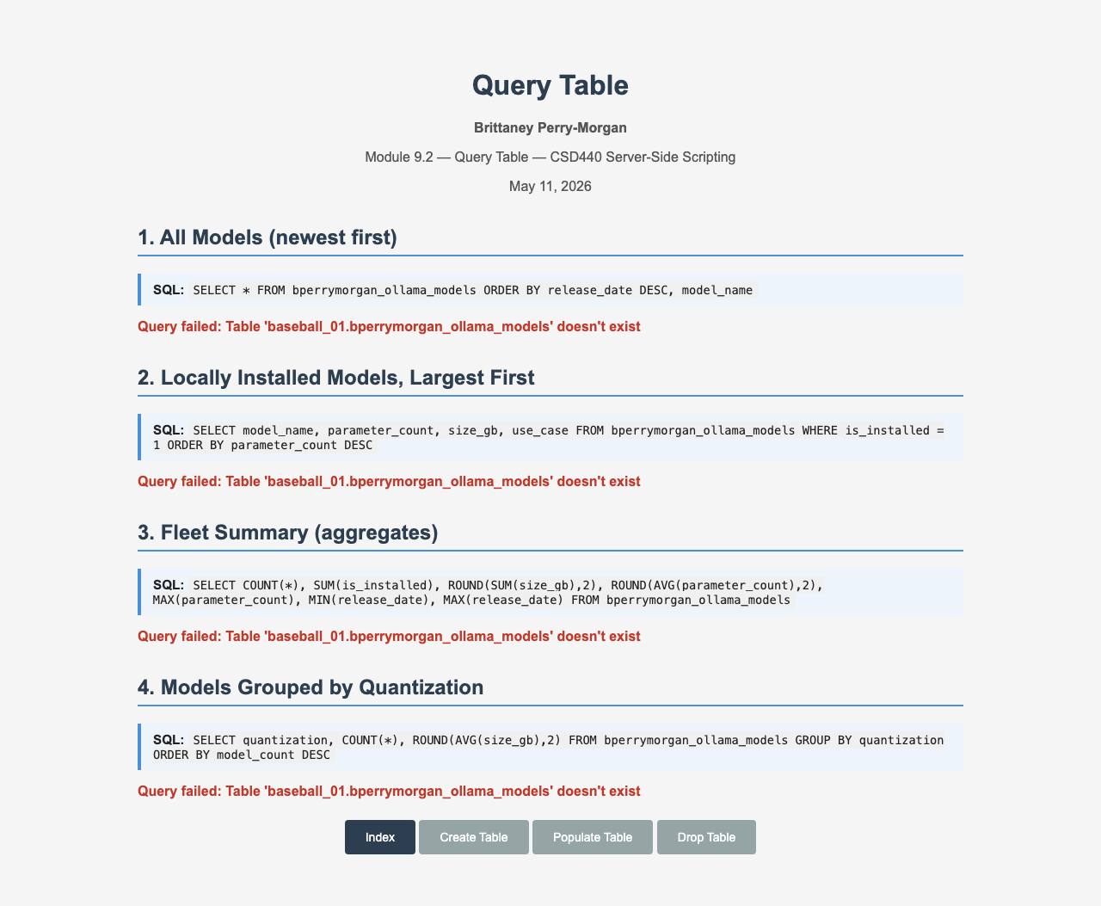

Add Record — INSERT fails without table
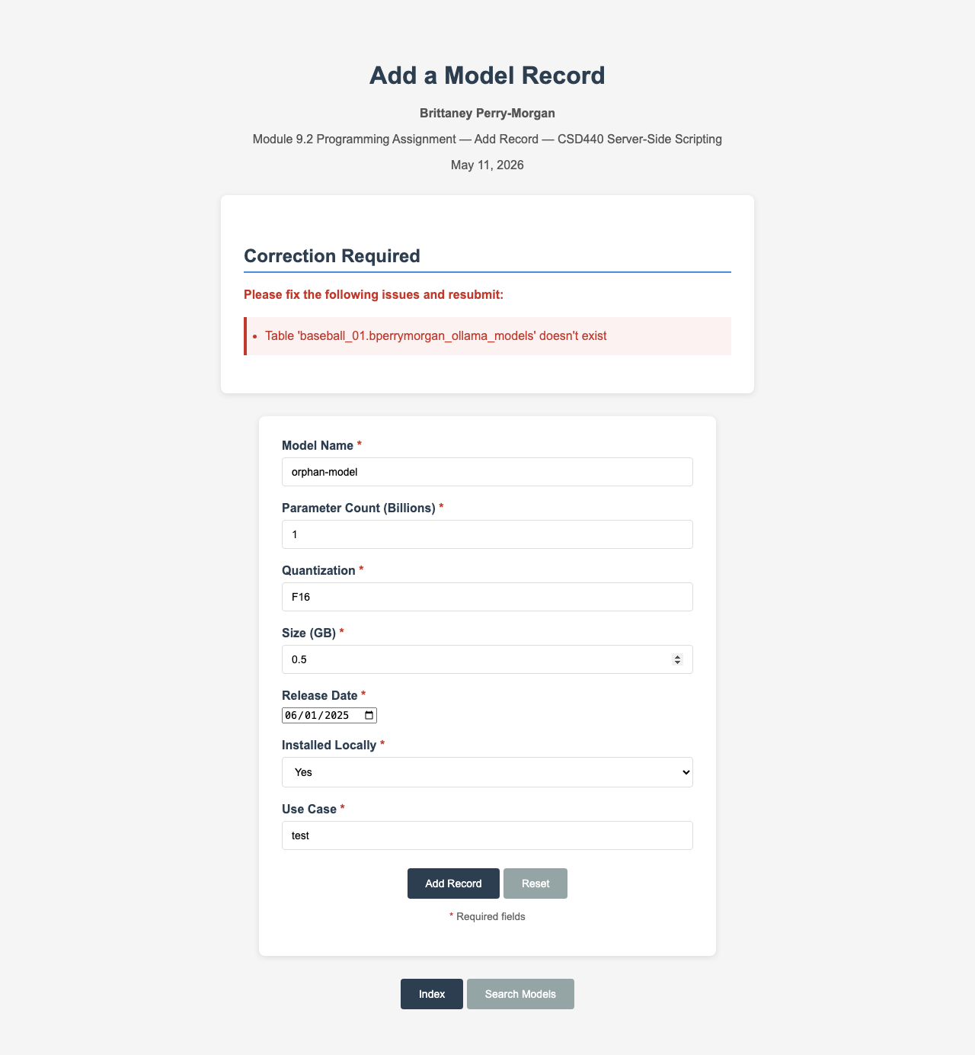

Create Table — Re-created after drop
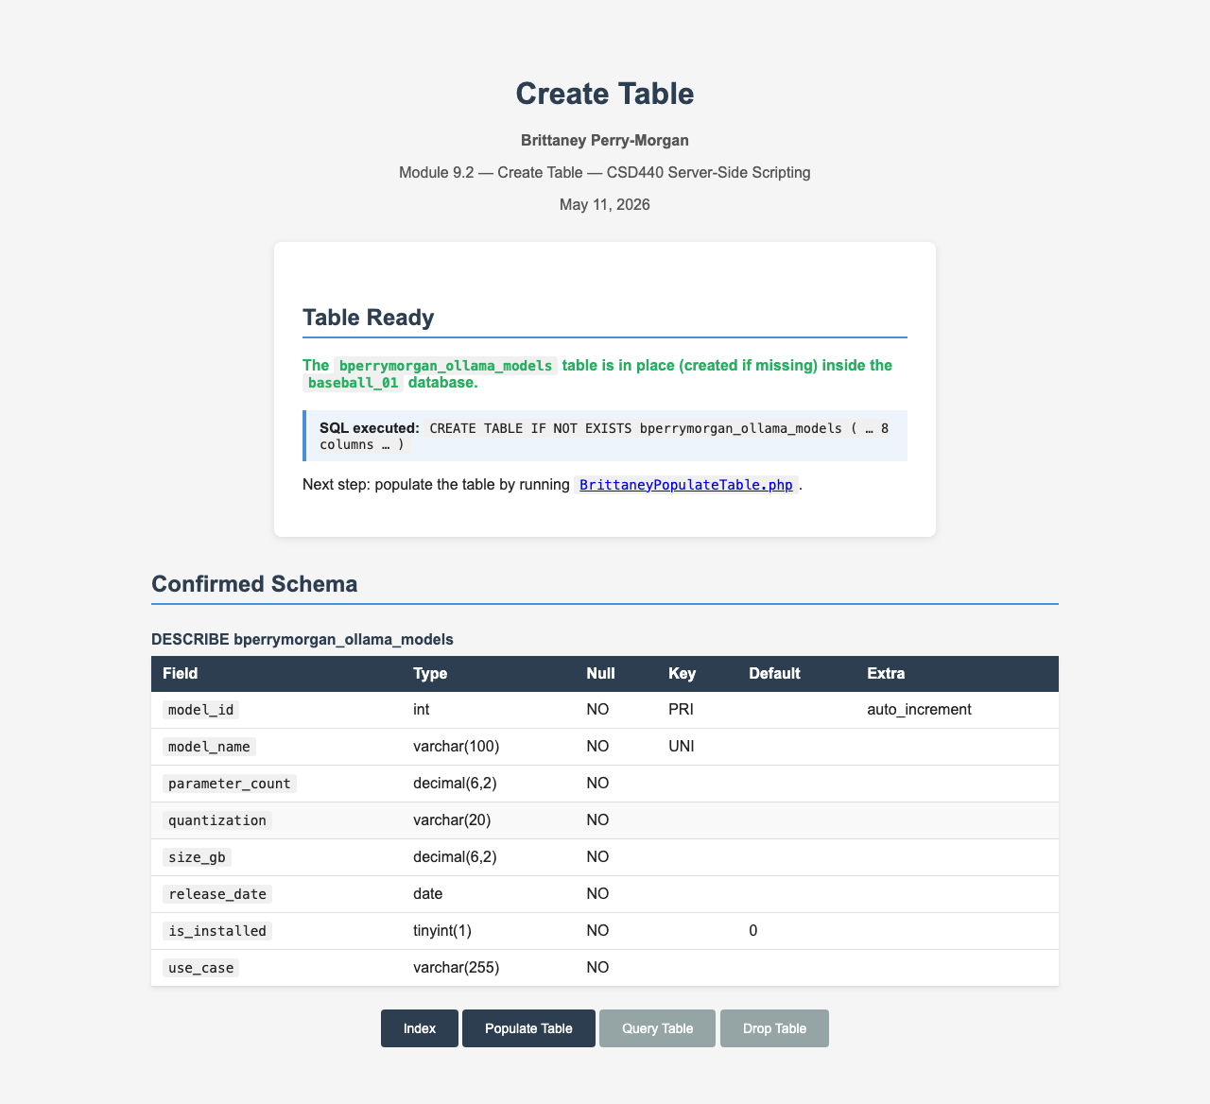

Populate Table — Re-seeded with 8 rows
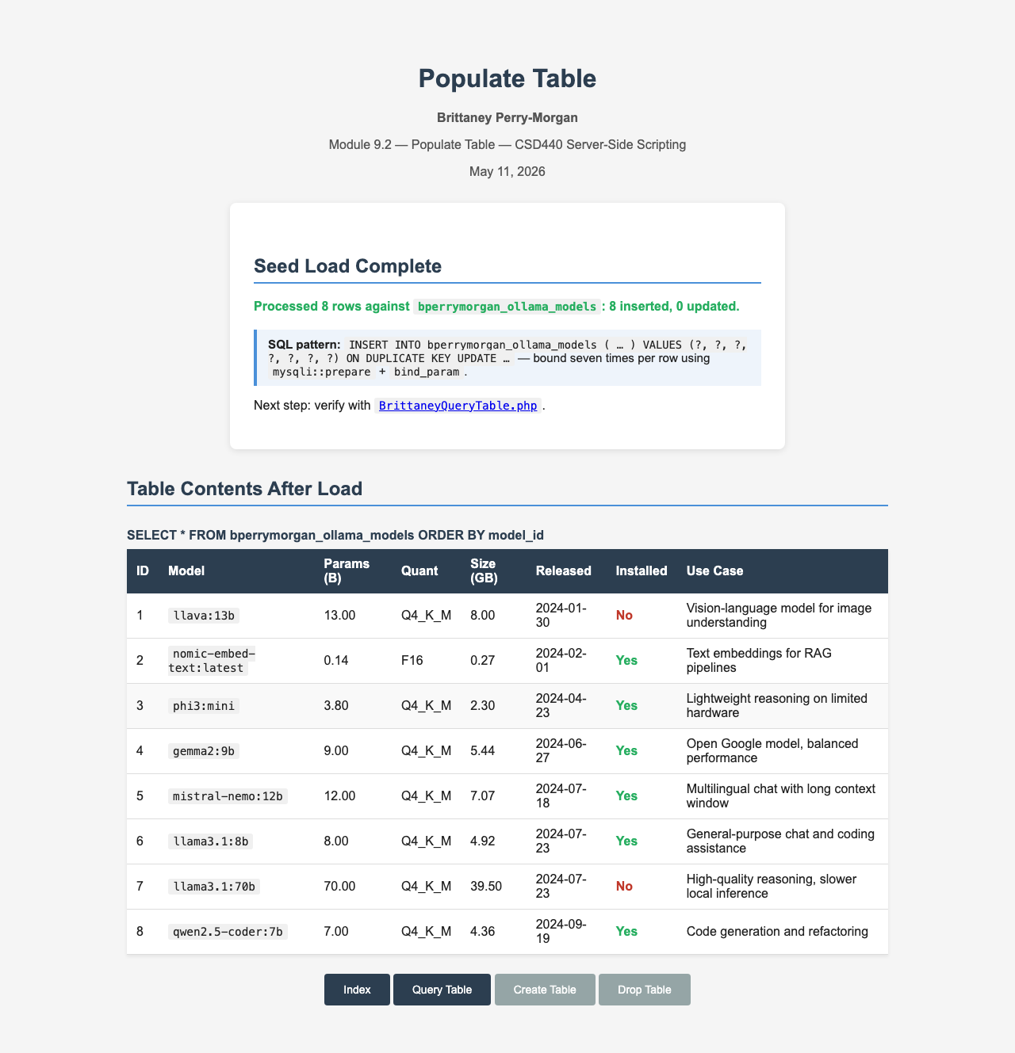

Index — Final state confirming 8 rows
